LOGICAL
OPERATIONS

EXP NO: 20

AIM:
To compute various logical operations
using 8085 processor.

ALGORITHM:

1) Load data to accumulator.

2) Load another data in register

3) Perform logical operations like AND, OR and XOR (Use ANA,
ORA, XRA) with the accumulator content.

4) Store the result in specified memory location.

PROGRAM:

XOR
OPERATION:

MVI
A,03

MVI
B,08

XRA
B

STA
2000

HLT

INPUT

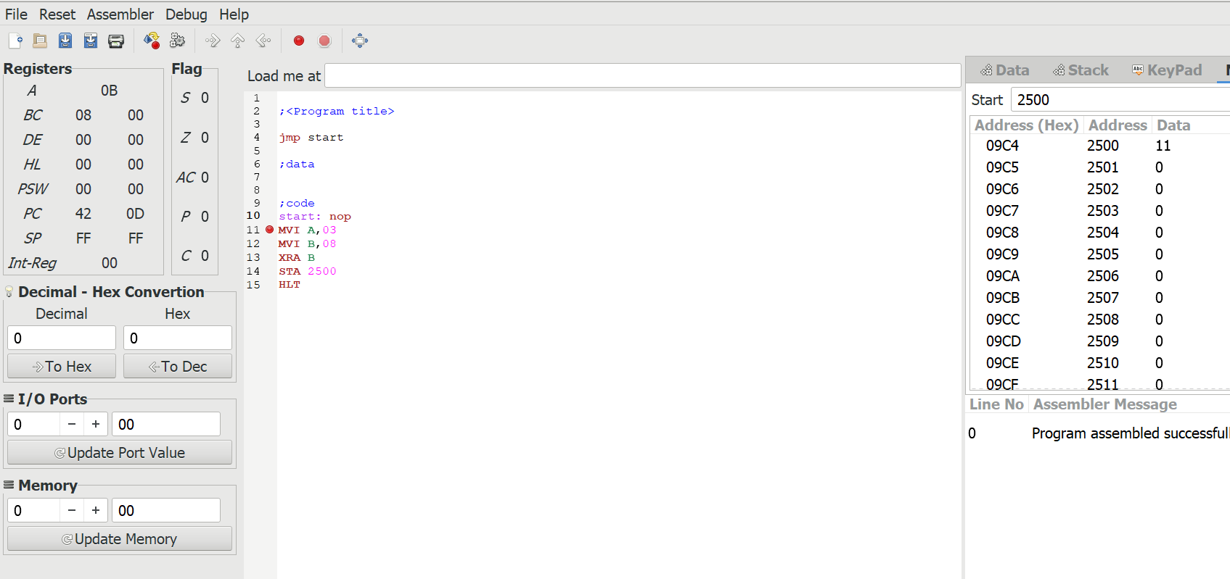

OUTPUT

